4th Grade Spelling

Regular List

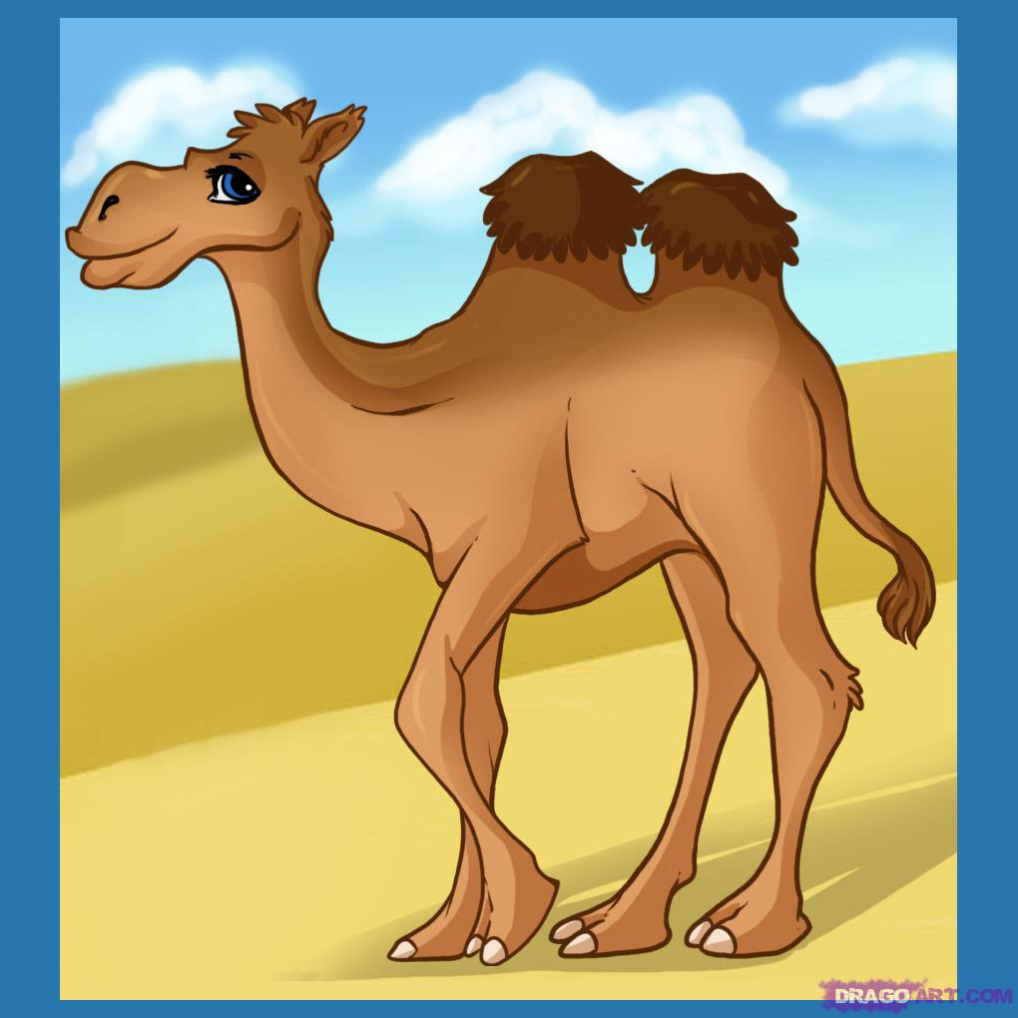
Unit 1
Lesson 3:
“My Librarian is a Camel”

Short i and Long i

1. skill
2. crime
3. grind
4. tonight
5. brick
6. flight
7. live
8. chill
9. delight
10. build
11. ditch
12. decide
13. witness
14. wind
15. district
16. inch
17. sigh
18. fright
19. remind
20. spilt

4th Grade Spelling

Regular List

Unit 1
Lesson 3:
“My Librarian is a Camel”

Short i and Long i

1. skill
2. crime
3. grind
4. tonight
5. brick
6. flight
7. live
8. chill
9. delight
10. build
11. ditch
12. decide
13. witness
14. wind
15. district
16. inch
17. sigh
18. fright
19. remind
20. spilt

4th Grade Spelling

Challenge List

Unit 1
Lesson 3:
“My Librarian is a Camel”

Changing y to i

1.tiniest
2. hobbies
3. copied
4. countries
5. pitied
6. easier
7. laziest
8. families
9. spied
10. happiest
11. ladies
12. friendlier
13. studied
14. busier
15. breezier
16. prettiest
17. noisier
18. healthier
19. butterflies
20. funniest

4th Grade Spelling

Challenge List

Unit 1
Lesson 3:
“My Librarian is a Camel”

Changing y to i

1.tiniest
2. hobbies
3. copied
4. countries
5. pitied
6. easier
7. laziest
8. families
9. spied
10. happiest
11. ladies
12. friendlier
13. studied
14. busier
15. breezier
16. prettiest
17. noisier
18. healthier
19. butterflies
20. funniest

