4th Grade Spelling

Regular List

Unit 1
Lesson 2:
“My Brother Martin”

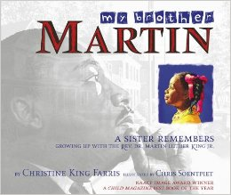
Short e and Long e

1. west
2. steep
3. member
4. gleam
5. fresh
6. freedom
7. speed
8. steam
9. beast
10. believe
11. speck
12. kept
13. cheap
14. pretend
15. greed
16. shelf
17. least
18. eager
19. reason
20. chief

4th Grade Spelling

Regular List

Unit 1
Lesson 2:
“My Brother Martin”

Short e and Long e

1. west
2. steep
3. member
4. gleam
5. fresh
6. freedom
7. speed
8. steam
9. beast
10. believe
11. speck
12. kept
13. cheap
14. pretend
15. greed
16. shelf
17. least
18. eager
19. reason
20. chief

4th Grade Spelling

Challenge List

Unit 1
Lesson 2:
“My Brother Martin”

Final Long e

1. turkey
2. lonely
3. colony
4. steady
5. hungry
6. valley
7. hockey
8. starry
9. melody
10. movie
11. duty
12. drowsy
13. chimney
14. plenty
15. daily
16. alley
17. fifty
18. empty
19. injury
20. prairie

4th Grade Spelling

Challenge List

Unit 1
Lesson 2:
“My Brother Martin”

Final Long e

1. turkey
2. lonely
3. colony
4. steady
5. hungry
6. valley
7. hockey
8. starry
9. melody
10. movie
11. duty
12. drowsy
13. chimney
14. plenty
15. daily
16. alley
17. fifty
18. empty
19. injury
20. prairie

